~Asia-China-Mirror-Warring States (475-221 BCE) - W. Han dynasty (206 BCE- 9CE) -leaf 4-arc 16, nipple 4-dragon 4

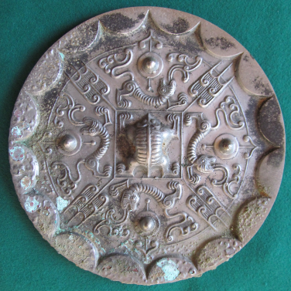

Warring States (475-221 BCE) - W. Han dynasty (206 BCE- 9CE) -leaf 4-arc 16, nipple 4-dragon 4

Rim: Inclined (16 continuous arcs).: Side: Slightly inclined inward.

Inner section: Square and monster at central knob; 4 leaves; 4 dragons around each of 4 nipples with bat-shaped "arrows"; high zinc bronze.

This type can be regarded as a product of late Warring States - early Western Han cosmology.

Both leaf and continuous arc designs appeared at the end of the Warring States period. The continuous arc motif represents the rays of the sun, and the leaf design evolved from auspicious beasts derived from the Shang taotie motif. This mirror depicts a celestial map anticipating the conceptual lines of the TLV mirrors.